**Day 1 of DevOps**

* Create a CloudWatch alarm that sends an email using SNS notification when CPU Utilization is more than 70%.
* Creating a Status Check Alarm to check System and Instance failure and send an email using SNS notification

Three-way Solution:

* AWS Console
* AWS CLI
* Terraform

What is CloudWatch?

* *AWS CloudWatch is a monitoring service to monitor AWS resources, as well as the applications that run on AWS. (For additional information follow the official page)*
* [What is Amazon CloudWatch? - Amazon CloudWatch](https://docs.aws.amazon.com/AmazonCloudWatch/latest/monitoring/WhatIsCloudWatch.html)
* We can use CloudWatch to collect and track metrics, which are variables you can measure for your resources and applications.

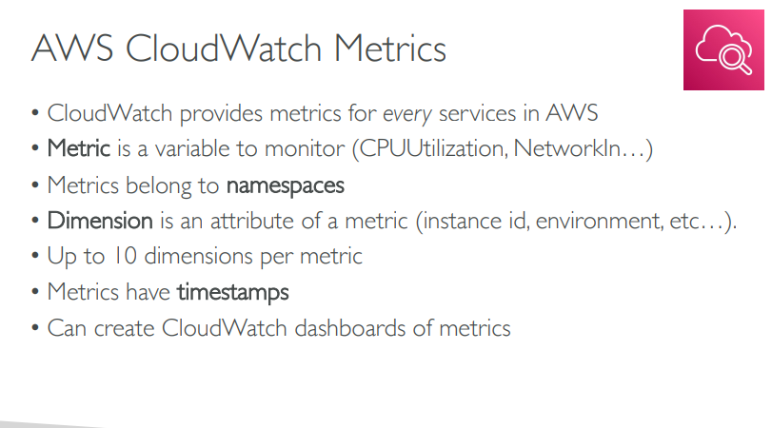

**EC2 Detailed Monitoring:**

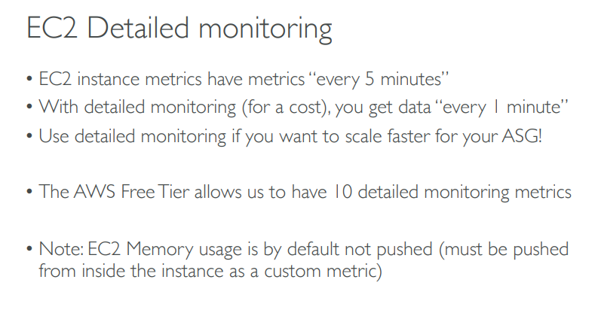

**CloudWatch Custom Metrics :**

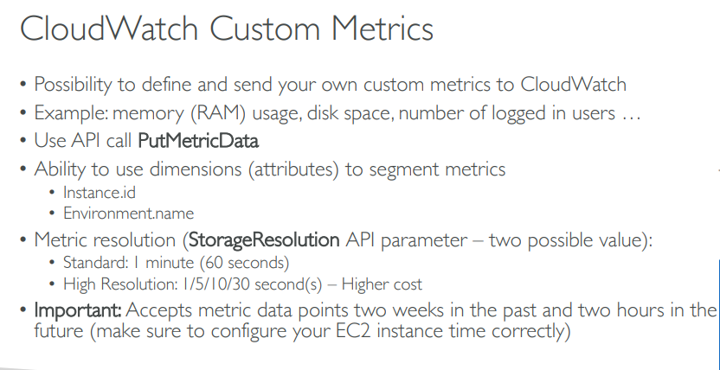

*EC2/Host Level Metrics that CloudWatch monitors by default consist of*

* ***CPU***
* ***Network***
* ***Disk***

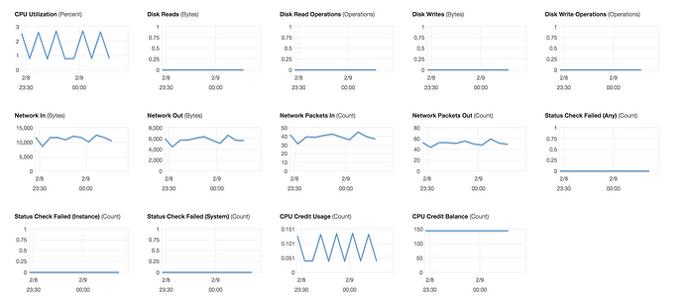

*Status Check*



*There are two types of status check:*

* System status check: Monitor the AWS System on which your instance runs. It either requires AWS involvement to repair or you can fix it by yourself by just stop/start the instance (in case of EBS volumes). Examples of problems that can cause system status checks to fail
* *Loss of network connectivity*
* *Loss of system power*
* *Software issues on the physical host*
* *Hardware issues on the physical host that impact network reachability*

*Instance status check:*

* *Monitor the software and network configuration of an individual instance. It checks/detects problems that require your involvement to repair.*
* *Incorrect networking or start-up configuration*
* *Exhausted memory*
* *Corrupted filesystem*
* *Incompatible kernel*
* *Memory/RAM utilization is custom metrics.*
* *By default, EC2 monitoring is 5 minutes intervals but we can always enable detailed monitoring (1 minutes interval, but that will cost you some extra $$$)*

Reference:

[*Amazon CloudWatch Pricing – Amazon Web Services (AWS)*](https://aws.amazon.com/cloudwatch/pricing/)

P.S: CloudWatch can be used on premise too. We just need to install the SSM (System Manager) and CloudWatch agent.

***Scenario1:***

*We want to create a CloudWatch alarm that sends an email using SNS notification when CPU Utilization is more than 70%*

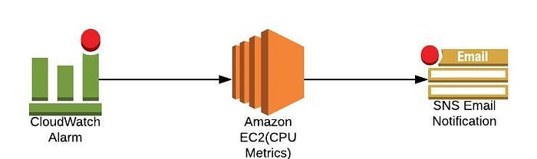

**Solution1: Setup a CPU Usage Alarm using the AWS Management Console**

*Open the CloudWatch console at*[*https://console.aws.amazon.com/cloudwatch/*](https://console.aws.amazon.com/cloudwatch/)*.*

*In the navigation pane, choose Alarms, Create Alarm.*

*Go to Metric → Select metric → EC2 → Per-Instance-Metrics → CPU Utilization → Select metric*

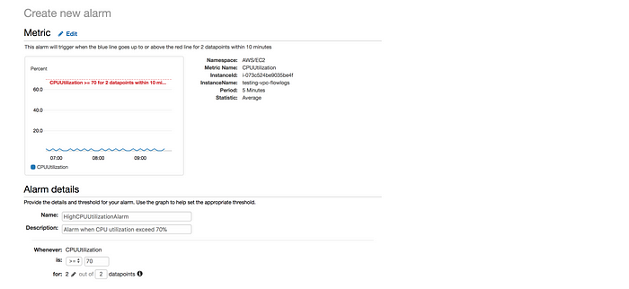

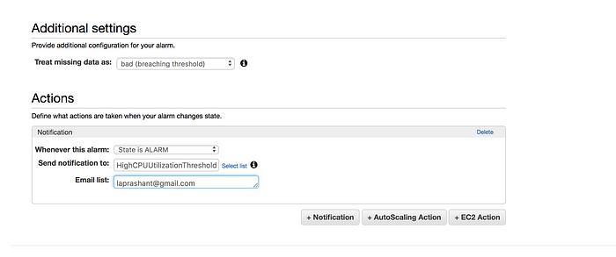

**Define the Alarm as follows\***

**Type the unique name for the alarm** (e.g.: High CPU Utilization Alarm)* **Description of the alarm**\* **Under whenever, choose** >= and type 70, for type 2. This specify that the alarm is triggered if the CPU usage is above 70% for two consecutive sampling period

* Under Additional settings, for treat missing data as, choose bad (breaching threshold), as missing data points may indicate that the instance is down* Under Actions, for whenever this alarm, choose state is alarm. For Send notification to select an existing SNS topic or create a new one

* To create a new SNS topic, choose new list, for send notification to type a name of SNS topic (for e.g.: High CPU Utilization Threshold) and for email list type a comma-separated list of email addresses to be notified when the alarm changes to the ALARM state.

* Each email address is sent to a topic subscription confirmation email. You must confirm the subscription before notifications can be sent.

* Click on Create Alarm

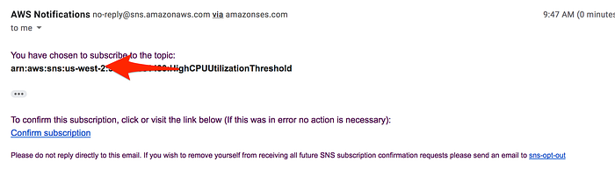

**Solution2: Setup CPU Usage Alarm using the AWS CLI**

* *Create an alarm using the put-metric-alarm command*

*aws CloudWatch put-metric-alarm --alarm-name cpu-mon --alarm-description "Alarm when CPU exceeds 70 percent" --metric-name CPU Utilization --namespace AWS/EC2 --statistic Average --period 300 --threshold 70 --comparison-operator GreaterThanThreshold --dimensions "Name=InstanceId,Value=i-12345678" --evaluation-periods 2 --alarm-actions arn:aws:sns:us-east-1:111122223333:MyTopic --unit Percent*

* *Using the command line, we can test the Alarm by forcing an alarm state change using a set-alarm-state command*
* *Change the alarm-state from INSUFFICIENT_DATA to OK*

*# aws cloudwatch set-alarm-state --alarm-name "cpu-monitoring" --state-reason "initializing" --state-value OK*

* *Change the alarm-state from OK to ALARM*

*# aws cloudwatch set-alarm-state --alarm-name "cpu-monitoring" --state-reason "initializing" --state-value ALARM*

* *Check if you have received an email notification about the alarm*

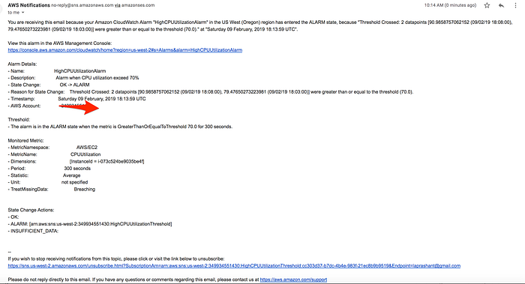

**Solution3: Setup CPU Usage Alarm using the Terraform**

#cloudwatch.tfresource "aws_cloudwatch_metric_alarm" "cpu-utilization" { alarm_name = "high-cpu-utilization-alarm" comparison_operator = "GreaterThanOrEqualToThreshold" evaluation_periods = "2" metric_name = "CPUUtilization" namespace = "AWS/EC2" period = "120" statistic = "Average" threshold = "80" alarm_description = "This metric monitors ec2 cpu utilization" alarm_actions = [ "${aws_sns_topic.alarm.arn}" ]dimensions { InstanceId = "${aws_instance.my_instance.id}" }}

*GITHUB link:*

Scenario2: Create a status check alarm to notify when an instance has failed a status check

Solution1: Creating a Status Check Alarm Using the AWS Console

1. *Open the Amazon EC2 console at*[*https://console.aws.amazon.com/ec2/*](https://console.aws.amazon.com/ec2/)*.*
2. *In the navigation pane, choose Instances.*
3. *Select the instance, choose the Status Checks tab, and choose to Create Status Check Alarm.*

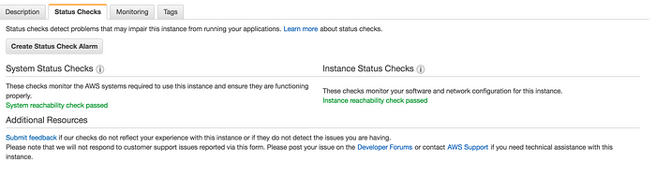

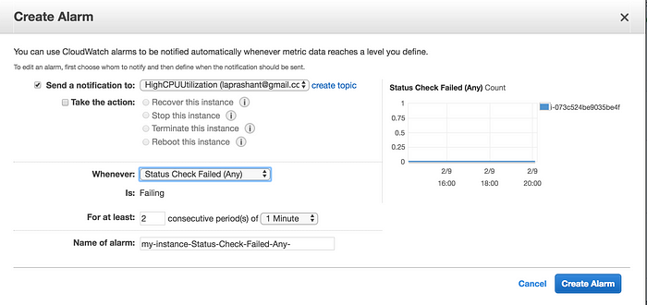

*\* You can create new SNS notification or use the exisiting one(I am using the existing one create in earlier example of high CPU utilization)  
* In* ***Whenever****, select the status check that you want to be notified about(options Status Check Failed(Any), Status Check Failed(Instance) and Status Check Failed(System)  
* In* ***For at least****, set the number of periods you want to evaluate and in* ***consecutive periods****, select the evaluation period duration before triggering the alarm and sending an email.  
* In* ***Name of alarm****, replace the default name with another name for the alarm.  
* Choose* ***Create Alarm****.*

**Solution2: To create a status check alarm via AWS CLI**

* ***Use the put-metric-alarm command to create the alarm***

*aws cloudwatch put-metric-alarm --alarm-name StatusCheckFailed-Alarm-for-test-instance --metric-name StatusCheckFailed --namespace AWS/EC2 --statistic Maximum --dimensions Name=InstanceId, Value=i-1234567890abcdef0 --unit Count --period 300 --evaluation-periods 2 --threshold 1 --comparison-operator Greater than or Equal to Threshold --alarm-actions arn:aws:sns:us-west-2:111122223333:my-sns-topic*

**Solution3: To create a status check alarm via Terraform**

resource "aws_cloudwatch_metric_alarm" "instance-health-check" { alarm_name = "instance-health-check" comparison_operator = "GreaterThanOrEqualToThreshold" evaluation_periods = "1" metric_name = "StatusCheckFailed" namespace = "AWS/EC2" period = "120" statistic = "Average" threshold = "1" alarm_description = "This metric monitors ec2 health status" alarm_actions = [ "${aws_sns_topic.alarm.arn}" ]dimensions { InstanceId = "${aws_instance.my_instance.id}" }}

GitHub